IET 104 – Industrial Management Seminars
Spring 2021 – Assessment 1

Student Name: Section:
Student ID: Date:
Grade:

Question 1:
The chart below is given to highlight on the process of Operations Management. Explain every stage, showing how entities go through this cycle and transform into outputs, and how operations managements can play a vital role along the way.(20 points)

Operation management majors on transfroms inputs which include capital, labor, equipment, land, raw materials as well as knowledge into outputs which include goods and services which provide added valueto clients. Each stage of transformation system involve
input each operation requires some form of input be it raw material, or capital
Transformation process; this is the process where the real vlue is added in our product through carrying out a number of transformation
Components: when conducting transformation processes we require some components such as special forms of tool.
External factors: there are a number of external factor which manages the opeations as well as the way of its execution these can involve market, suppliers, competition, economu and government regulations
Measurement: this is part of monitoring the products as well as the process in this satge. We assess if we are attaining our targets.
Feedback: the response part is among the most essential and crutial part of our operation fory any operation to be profitable for long feedback stage is needed in the process the shortcoming of the items are fed into the system.
Adjustment: a good manager will attempt to minimize cost and may remove the under performing process in order for the entire operation to become successful.
Question 2:

The following Graph represents the percentage of goods and services offered by several organizations: (25 points)

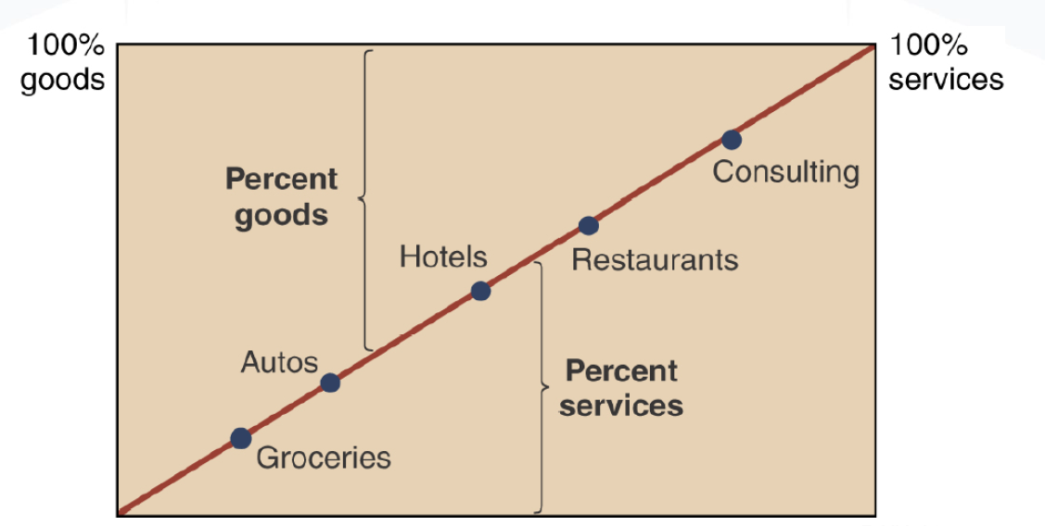

- Give two examples of a Good and a Product.
Good example tables, cups
Examples of Product include tables, chairs, cars, swimming
Using the Graph, approximate the percentage of services and percentage of goods offered by Restaurants. Explain these percentages.
the percentage of services in the restraunt is 80% while the percentage of goods offered in a restraunt is 20% this is because a restraunt mainly majors on the intangible products. Basically it mainly majors on serving the clients.
- Using the Graph, approximate the percentage of services and percentage of goods offered by Groceries. Explain these percentages.
The percentage of services offered by groceries is 20% while the percentage of the goofs offered by groceries is 80%. This is because groceries major on providing goods to the clients instead of services.
- In your opinion, is it possible to consider only the goods offered by a Restaurant or the only the services alone as a factor that leads to customer satisfaction? Explain your answer.
I believe that a restaurant cannot satisfy customers by only considering only the goods offered by the facility or only the services. This is because these factors tend to impact clients different. Clients required both the goods and services in order for them to meet the clients needs.
- What is the main purpose of operations management?
The main purpose of operation management is to utilize the resource of the organization, to develop such products or services which meet the needs of the customers. It as well aims at making the best possible use of the firm’s resources to meet the needs of the clients.

Question 3: (15 points)

State whether the following statements are true or false. If the statement is false, write the correct answer:

- Aiming for low quality production leads to high customer satisfaction. False

Answer: poor quality products and services can have a major impact on customer atifaction. These goods and services can result to the lose of customers faster than they can gain new ones.

- A good is an intangible asset since it does physically exist and add potential revenue to the organization. False

Answer: a good can either be tangible and intangible assets. There are goods that physically exist and there are goods which do not physically exist.

- Operation management leads to an increase in competition between companies, hence increasing product quality. True
Answer:

- Operation management focuses on increasing product value and achieving higher productivity for the highest possible cost. True

Answer:

- Good management involves monitoring the working environment and ensuring that everything is going according to plan.True
Answer:

Question 4: (40 points)

Clearly answer the following questions:

- In your opinion, how does good management in a organization contribute to the success of this organization?
Good management in a firm aids in enhancing successing since through it there is effective planning which aids in ensuring that goals are attained within a short or long time. In addition it as well aids in providing a sense of focus as well as direction. It aids in easily identifying the issues as well as the ways to cope with them. Good management as well enhances good communication where employees have a chance to express themselves and due to this issues that are arising can be handle in an effective manner.
- What is globalization? Why is globalization classified as a managerial issue?
Globalization refers to the free movement of goods, serervices as well as people all over the world in a seamless as well as integrated way. It is the outcome of the opening up of the world wide economy as well as concomitant increase in trade between countries. Globalization has impacted management in a number of ways. Globalization has impacted management through market as client base, international employee transfer rates, competition as well as increase in opportunities.
- Operation Management is considered as a cyclic process. Explain why?
Operation management is acyclic process since it involves a number of processes: plan, direct, control, improve, decide and back to plan again. Planning aids in determining that which organization’s key objectError! Hyperlink reference not valid.ive are and then identifies plans on how to attain them. Directing involves the process of ensureing effective as well as efficient operations in a firm. Controlling involves assessing the firm’s performance in comparison to its plans. Improve assists the firm to make continuous improvements in the firm and the last phase is deciding gives the managers the ability to choose the most appropriate alternative course of action.
- Give an example of a product you believe has low quality and state at least three reasons for your opinion.
Levis jeans is one of the product that I believe is of low quality. These jeans had a short lifespan; there were way cheaper in comparison to other types of jeans and the jeans were designed in a way that there were hard to put on.

- Based on your answer in question 4, apply operations management to the transformation process of this product to increase its quality. (At least three ideas)
The producers of the levis jeans should major on making the jeans simple in order to improve their ability to be worn, they should as well use high quality clothing to make the attire in order to increase its lifespan. The firm should as well aim at finding the clients to validate the product quality by arranging calls with theindurstry analysts, industry press and motivate them to reviews online.
Note:
Please do not Copy and Paste from any source – Try to answer in your own words.
Goodluck!

